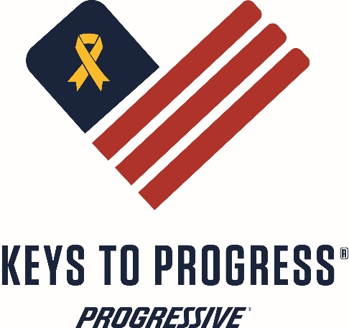
Criteria for Progressive Keys to Progress Program
Veteran Recipient Criteria
- Must be able to provide a DD214
- Must fall below 200% of the federal poverty guidelines table issued by the Department of Health and Human Services
- National Income Limits (click “a chart with percentages of the guidelines” under “Resources” on the right side of the page.)
- Have a valid driver’s license
- Have a clean driving record – no major infractions in the past 7 years.
- Be able to insure and maintain the vehicle
- Does not own a vehicle or show a hardship with current vehicle
- One Year Income Tax
- Must be able to pass a background check
Veteran Recipient’s Legal Obligations and Liabilities
- Title transfer fees
- Pay all applicable sales tax and fees after 1yr of ownership
- Insurance coverage after the first six months of ownership
Please remember that the recipient is legally required to obtain and continue insurance coverage.

Criteria for Progressive Keys to Progress Program
Veteran’s Information *Required
Name*:
Address*:
City*: State*: Zip*:
Phone*: Rent* Own*
Valid Driver’s Lic. No.*:
^{Number} ^{State} ^{Expiration Date}
Primary driver(s) in your household:_________________________________________
Marital Status*: Single Married Separated Divorced
Excluding veteran, please list all dependents residing in the home*:
Name Age Relationship
Name Age Relationship
Name Age Relationship
Name Age Relationship
Name Age Relationship
Do you or your spouse own a registered motor vehicle*? Yes No
If yes:
^{Year} ^{Make} ^{Model} ^{VIN Number}
^{Year} ^{Make} ^{Model} ^{VIN Number}
Insurance information that covers your vehicle:
^{Company} ^{Insured} ^{Policy Number} ^{Policy Term}
Income:
Veteran Monthly Income*: Spouse/Fiancé(e)/Roommate Monthly Income*:
$ $
Additional Monthly Income*:
Type Amount: Type Amount
VA Benefits Unemployment
Child Support (received) SSI/SSDI
Welfare Food Stamps
Other
Total Monthly Income*:
Have you ever been convicted of a felony? Yes No
Applicant signature confirms they understand proper stewardship requires they provide the necessary information to substantiate their request; including governmental records, income information, and current driving records. The applicant understands this information will be kept confidential. Applicant understands if they receive a vehicle through the Keys to Progress Program, Progressive Insurance Company as well as its affiliates and subsidiary companies, will not be liable for any related maintenance or upkeep of the vehicle after commencement of the ceremony. Applicant understands that background research will be conducted on potential vehicle recipients. Applicant consents to same and agrees to cooperate with any such research effort.

Veteran Applicant Signature* Printed Name*
Date*
In your own words, please tell us why you are in need of a vehicle from the Keys To
Progress program; and how the vehicle will impact your life. (You may also send this in your own word processor document or email program.)
_____________________________________________________
_____________________________________________________
_____________________________________________________
_____________________________________________________
_____________________________________________________
_____________________________________________________
_____________________________________________________
_____________________________________________________
_____________________________________________________
_____________________________________________________
_____________________________________________________
_____________________________________________________
_____________________________________________________
_____________________________________________________
_____________________________________________________
_____________________________________________________
_____________________________________________________
_____________________________________________________
_____________________________________________________
_____________________________________________________
_____________________________________________________
_____________________________________________________
________________________________________________________
___________________________________________________________
___________________________________________________________
(Please feel free to continue on back if needed)

